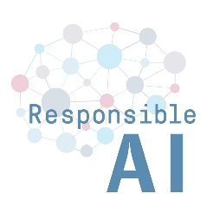

Global Perspectives on Responsible AI 2020
Registration Form
June 25/26 2020

PLEASE RETURN NOT LATER THAN JUNE 14 2020 TO
ai2020@frias.uni-freiburg.de

My Name ________________________

My Affiliation _____________________

My Email Address _______________
I want to take part in the Conference via Zoom* (YES / NO)

FIRST DAY
on June 25 - whole day ________

OR

on June 25 - morning sessions _______

on June 25 - after lunch and afternoon sessions ________

on June 25 - evening sessions _______________

SECOND DAY

on June 26 - whole day ________

OR

on June 26 - morning sessions _______

on June 26 - afternoon sessions ________

on June 26 - evening session ________

By taking part I agree to accept the terms and conditions for using Zoom and agree that sessions might be recorded.

________________________________________________________________________________
For further information see our website https://responsible-ai.org/

Contact:

Prof. Wolfram Burgard (Robotics) – Dr. Philipp Kellmeyer (Neurology & Neuroethics) –
Prof. Oliver Müller (Philosophy) – Prof. Dr. Silja Vöneky (Law & Ethics of Law)

c/o
Team Saltus Responsible AI
FRIAS
Freiburg University
Germany

Email: ai2020@frias.uni-freiburg.de

