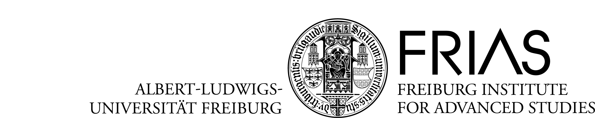

Application for
Junior Researcher Workshops/Conferences
(Sept. 2021 – April 2022)

Application deadline: November 30, 2020

Please fill in the following interactive pdf-application-form in English.

The completed application form together with the required documents in English has to be submitted to Dr. Verena Schröter at verena.schroeter@frias.uni-freiburg.de by November 30, 2020; 24.00 h CET. Please submit the electronic application in one single PDF.

Index: 1. Applicant’s details
2. Details of the workshop/conference
3. Declaration of consent

1. Applicant’s details

Applicant 1
Last name
First name(s)
Current academic position
Department/ institute/ seminar
University
Business address (to be used for correspondence)
Phone number
Email
Do you hold a position at the of the University of Freiburg both at the time of application and the time of the conference?

Applicant 2
Last name
First name(s)
Current academic position
Department/ institute/ seminar
University
Business address (to be used for correspondence)
Phone number
Email
Do you hold a position at the of the University of Freiburg both at the time of application and the time of the conference?

Applicant 3
Last name
First name(s)
Current academic position
Department/ institute/ seminar
University
Business address (to be used for correspondence)
Phone number
Email
Do you hold a position at the of the University of Freiburg both at the time of application and the time of the conference?

Applicant 4
Last name
First name(s)
Current academic position
Department/ institute/ seminar
University
Business address (to be used for correspondence)
Phone number
Email
Do you hold a position at the of the University of Freiburg both at the time of application and the time of the conference?

Applicant 5
Last name
First name(s)
Current academic position
Department/ institute/ seminar
University
Business address (to be used for correspondence)
Phone number
Email
Do you hold a position at the of the University of Freiburg both at the time of application and the time of the conference?

2. Details of the workshop/conference

Title of the workshop/conference (max. 200 characters, in English)

Proposed dates for the workshop/conference. (It is recommended that applicants consult FRIAS - see contact below - beforehand regarding the dates.)
If available - number of invited Freiburg speakers who have confirmed their participation (except organisers).
Number of invited external speakers.
If available - number of invited external speakers who have confirmed their participation.
Number of further registered participants expected from Freiburg or elsewhere. (Max. 50, For organizational reasons participation in the workshop is only possible after registration. )
Requested funding (It is recommended that applicants consult FRIAS - see contact below - beforehand regarding the budget.)
Remarks

3. Declaration of consent

I hereby declare that the above statements are correct:

The Freiburg Institute for Advanced Studies (FRIAS) has my permission to electronically keep and process my personal information for the purpose of peer review, statistics, and evaluation by the FRIAS as well as its commissaries.
Date (dd.mm.yyyy) |  | Name

Documents required:

The following documents are required to submit the application:

- Completed application form
- Presentation of the event´s topic including a concise outline of the leading questions and goals.
(max. 5 pages, including possible references, tables and figures). Emphasis has to be laid on the particular of the conference and how the goals are going to be realized with the conference.
- List of Freiburg speakers. (Name, work address and position, email address.) Mention tentative acceptances if available.
- List of invited external speakers. (Name, work address and position, email address.) Mention tentative acceptances if available.
- Program structure: presentation of the workshop/conference schedule (max. 2 pages, graph presentation possible.)
- Calculation of costs (refer to instructions on www.frias.uni-freiburg.de/nachwuchstagungen). It is recommended that applicants consult FRIAS - see contact below - beforehand regarding the budget.
- CVs of all applicants in tabular form with list of publications (max. 1 page each).

Page limits may not be exceeded.

For further details please contact Jennifer Foster (jennifer.foster@frias.uni-freiburg.de) .

Documents 1-7 have to be included in one single PDF-file and be sent to verena.schroeter@frias.uni-freiburg.de by November 30, 2020.

