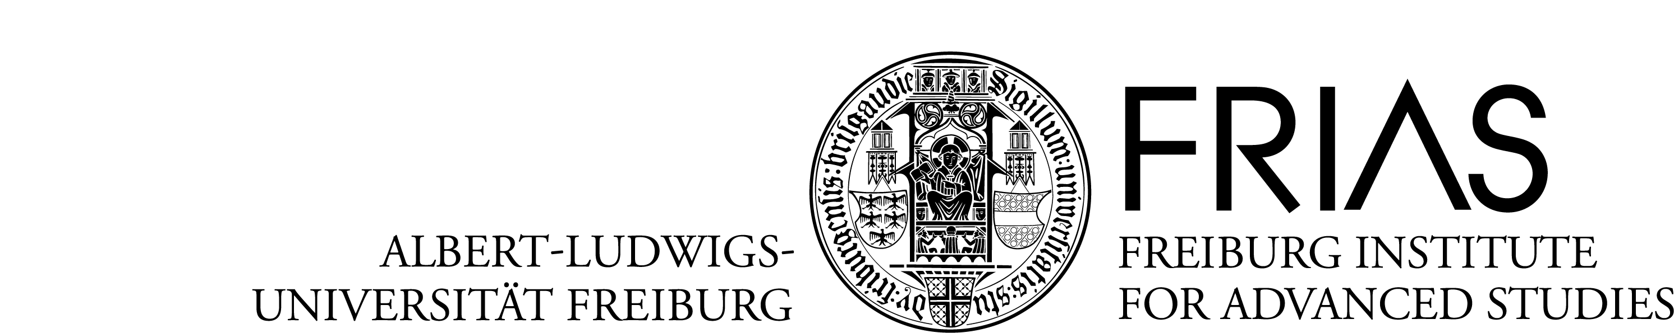

Application for
Internal Junior Fellowships at FRIAS
(Oct. 2021 – Jul. 2022)

Application deadline: November 30, 2020

Please fill in the following application-form in English.

Please submit the electronic application in one single PDF, including the application form, a project proposal (up to 6 pages including citations), a CV (max. 2 pages) and a publication list (max. 2 pages) in English to katrin.brandt@frias.uni-freiburg.de by November 30th, 2020.

Index: 1. Applicant’s details
2. Details of research project
3. Declaration of consent

1. Applicant’s details

A. Applicant’s personal details
Surname
First name(s)
Date of birth (dd.mm.yyyy)
Gender (m/f/d)
Nationality
Date of doctorate (dd.mm.yyyy)
University of doctorate

B. Current academic position
Position (Junior professor/Lecturer/Research assistant/other)
If other, please specify
Since (mm.yyyy)
Until (mm.yyyy)
Department/ institute/ seminar
Faculty
Do you hold a temporary state position at the University of Freiburg for the duration of the funding period (October 2021 to July 2022)?
Do you finance your own position at the University of Freiburg through third-party funding raised by yourself for the duration of the funding period (October 2021 to July 2022)?
The submission of this application has the approval of my direct supervisor (Dienstvorgesetze/r).
Supervisor (Name/ email)

C. Business address (to be used for correspondence)
Department/ institute
Street, P.O. box
Postal code/ city/ country
Phone number
Email address

2. Details of research project

A. Research field of proposed research project
1.
2.

B. Title of proposed research project in English (max. 200 characters)

English text

C. Abstract describing the project English (max. 1500 characters)
English text

E. Broader envisaged impact of the planned research project and the FRIAS fellowship on your academic career (max. 1500 characters, in English).

F. Suggestion of external experts for the international peer-review process (OPTIONAL)
Please provide contact details of three potential, non-biased international reviewers who would be suitable to evaluate your application.

Reviewer 1 | Name
 | Web page
Reviewer 2 | Name
 | Web page
Reviewer 3 | Name
 | Web page

3. Declaration of consent

I hereby declare that the above statements are correct:

The Freiburg Institute for Advanced Studies (FRIAS) has my permission to electronically keep and process my personal information for the purpose of peer review, statistics, and evaluation by the FRIAS as well as its commissaries.
Date (dd.mm.yyyy) |  | Name

Documents required:

The following documents are required to submit the application:

1. Completed application form
2. Project proposal (max. 6 pages incl. references) including:
a. Aims, theoretical framework and methodology of the project
b. Working programme and feasibility
c. Budget estimation
3. CV in tabular form (max. 2 pages)
4. Publication list (max. 2 pages, highlighting the most important project-specific publications)

Page limits may not be exceeded.

Please submit materials 1 – 4 in one pdf-file (linespacing 1.5, font arial 11 pt, all margins 2.5 cm, in English) to katrin.brandt@frias.uni-freiburg.de by November 30th, 2020.

